Chapter 15, Solution 28.

Design a problem to help other students to better understand how to find the inverse Laplace transform.

Although there are many ways to solve this problem, this is an example based on the same kind of problem asked in the third edition.

Problem

Find the inverse Laplace transform of the following functions:
(a) 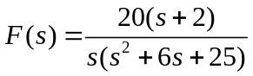
(b) 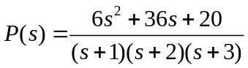

Solution

(a) 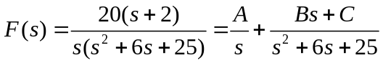

Equating components,
s² : 0 = A + B or B= - A
s: 20 = 6A + C
constant: 40 – 25 A or A = 8/5, B = -8/5, C= 20 – 6A= 52/5

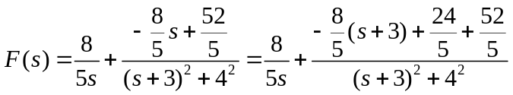

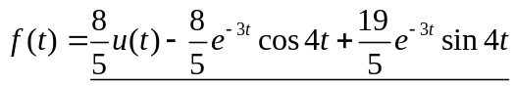

(b) 